BUSINESS BLUEPRINT

Document information
Project Name | VinaTech Smart Manufacturing's order status management system
Module | MM – Material Management
Created by | QuyNT
Version | 1.0
Date | 28/02/2026

Table of Contents
1 OVERVIEW 3
1.1 Glossary 4
1.2 Flow chart shapes usage 5
2 ORGANIZATION STRUCTURE 6
2.1 Sales organization and Sales group 7
2.2 Plants and storage locations 8
3 MASTER DATA 9
3.1 MM-MD-01 Material Master Process 10
3.1.1 Material Type 11
3.1.2 Material group 12
3.1.3 Flowchart 13
3.1.4 Description 14
3.2 MM-MD-02 Vendor Master Data Process 15
3.2.1 Flowchart 16
3.2.2 Description 17
3.3 MM-MD-02 Pricing Master Data Process 18
3.3.1 Pricing Procedures 19
3.3.2 Pricing condition types 20
Flowchart 21
Description 22
4 PROCUREMENT PROCESS 23
4.1 MM-BP- Local Procurement Process 24
4.1.1 Flowchart 25
4.1.2 Description 26

OVERVIEW

Glossary
Term | Definition | Note
FPTU | FPT University
BP | Business Blueprint
DB | Database
V | Version
FI | Finance
MM | Material Management
IM | Inventory Management

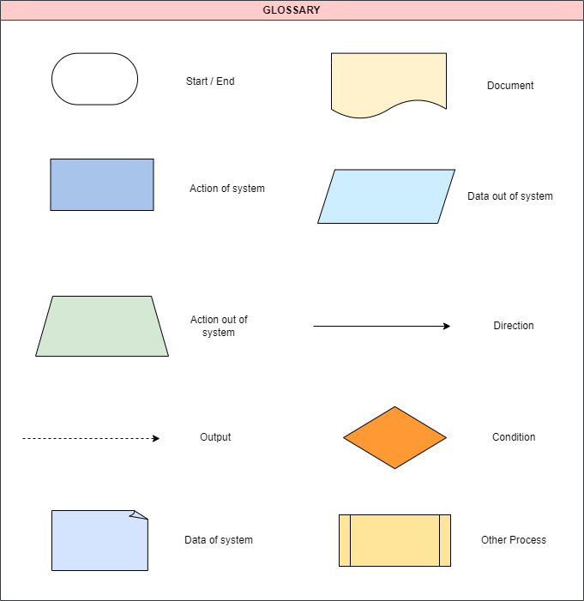
Flow chart shapes usage

2. ORGANIZATION STRUCTURE

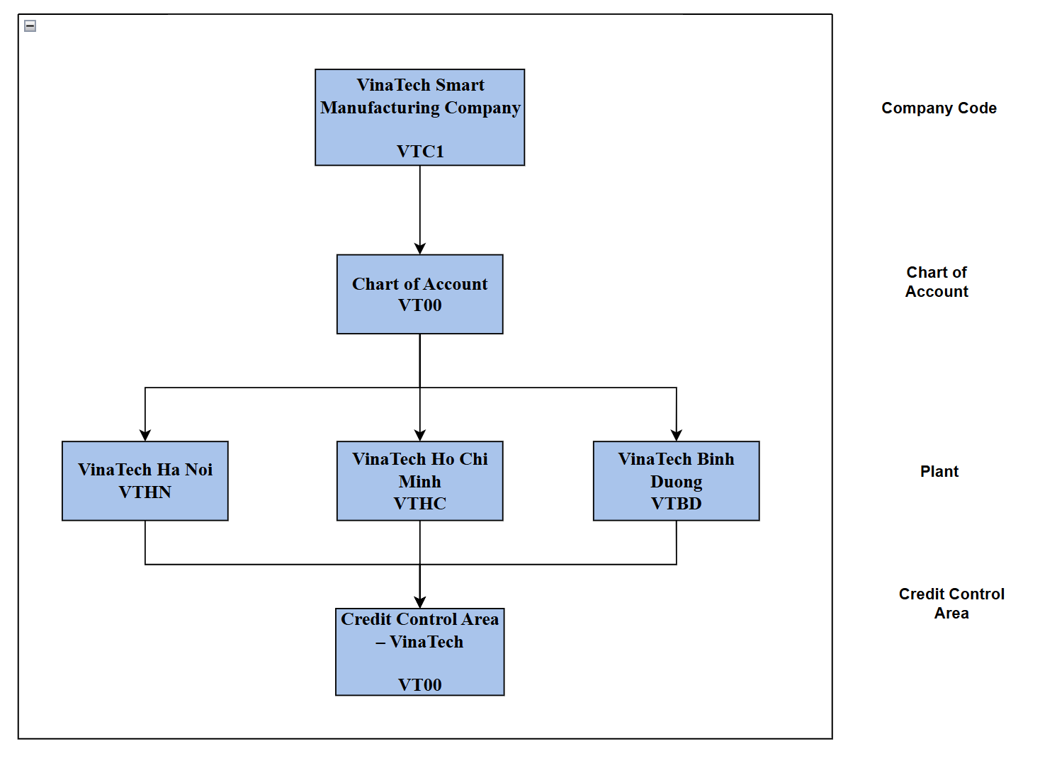

Sales organization and purchasing group
Sales Organization
The selling activity for a plant takes place within the sales organization, which is the organizational unit responsible for selling products and managing customer contracts. It plays a central role in the company’s sales process by handling negotiations with customers on sales conditions, pricing agreements, and other commercial terms. Through the sales organization, the company is able to coordinate and manage all activities related to product distribution and customer transactions in an effective and structured manner.
Sales organization | Sales organization Description
VTC1 | VinaTech Smart Manufacturing

Sales Group
Sales group is the key that represents the sales representative or a group of sales representatives responsible for specific sales activities and serving as the communication channel between VinaTech and its customers.
Sales Group | Sales group Description
KAM | Key Account Management
CST | Channels Sales Team

Plants and storage locations
Plants are organizational units used to structure the enterprise according to production, procurement, maintenance, and material planning activities. A plant represents a physical location where electronic components are manufactured, assembled, stored, and distributed to customers. Each plant operates as an independent operational unit within the company and is assigned to a single company code, while one company code may include multiple plants. In addition, each plant maintains its own material master data and inventory management structure. At VinaTech Smart Manufacturing (Company Code: VTC1), the company operates three manufacturing plants.
Configuration Data:

Plant | Storage Location Number | Storage Location Description
VTHN | FG01 | finished product
 | RM01 | semi-finished products
VTBD | FG01 | finished product
 | RM01 | semi-finished products
VTHC | FG01 | finished product
 | RM01 | semi-finished products

MASTER DATA

MM-MD-01 Material Master Process

Material Type
Material type is a key classification attribute in SAP that defines the basic nature of a material. They determine the attributes and behaviors of a material in the system, such as the number assignment, screen layout, and account assignment category. Material type is used to group materials that have similar characteristics or are used for similar purposes.
Material Type | SAP Description | Description
FG01 | Finished Goods | Finished electronic boards for sales

Material group
Material group is another classification attribute in SAP that is used to group materials for reporting and analysis purposes. It is a way to categorize materials based on common characteristics such as material properties, usage, or business requirements. Material group is a higher-level classification compared to material type and is used for organizing materials for reporting, planning, and analysis purposes, and can be used to group materials across different material types and assigned to a material master record to help organize and classify materials in the system.
Material Type | Material Group | Material | Material Description
FG01 | BM01 | PCB02 | Bo mạch điều khiển động cơ Servo 220V
 |  | PCB03 | Bo mạch điều khiển PLC mini 8 ngõ vào/ra
 |  | PCB07 | Bo mạch điều khiển hệ thống chiếu sáng LED
 |  | PCB011 | Bo mạch điều khiển robot tự động hóa
 |  | PCB012 | Bo mạch điều khiển băng tải sản xuất
 |  | PCB014 | Bo mạch điều khiển hệ thống cửa tự động
 |  | PCB016 | Bo mạch điều khiển máy CNC mini
 |  | PCB018 | Bo mạch điều khiển hệ thống HVAC
 |  | PCB019 | Bo mạch điều khiển thang máy mini
 |  | PCB020 | Bo mạch điều khiển máy đóng gói tự động
 | BM02 | PCB005 | Bo mạch nhúng ARM Cortex-M4 STM32F407
 |  | PCB006 | Bo mạch IoT công nghiệp tích hợp WiFi/Bluetooth
 | BM03 | PCB004 | Bo mạch xử lý tín hiệu ADC/DAC độ chính xác cao
 |  | PCB015 | Bo mạch xử lý hình ảnh camera công nghiệp
 |  | PCB010 | Bo mạch giao tiếp RS485/Modbus công nghiệp
 |  | PCB013 | Bo mạch giám sát nhiệt độ và độ ẩm
 | BM04 | PCB001 | Bo mạch điều khiển nguồn DC 24V công nghiệp
 |  | PCB008 | Bo mạch điều khiển inverter biến tần 3 pha
 |  | PCB009 | Bo mạch điều khiển hệ thống năng lượng mặt trời
RM01 |  | PCB017 | Bo mạch quản lý pin BMS 48V
 | LK01 | LK001 | Điện trở 10K Ohm
 |  | LK002 | Điện trở 1K Ohm
 |  | LK003 | Cuộn cảm 10mH
 |  | LK004 | Cuộn cảm 5mH
 | LK02 | LK005 | Diode chỉnh lưu 1N4007
 |  | LK006 | Diode Schottky SS14
 |  | LK007 | Transistor NPN BC547
 |  | LK008 | Transistor MOSFET IRF540
 |  | LK009 | IC nguồn LM2596
 |  | LK010 | IC khuếch đại LM358
 |  | LK011 | Vi điều khiển STM32F103
 |  | LK012 | Vi điều khiển ATmega328
 | LK03 | LK013 | Cảm biến nhiệt độ PT100
 |  | LK014 | Cảm biến áp suất 0-10 Bar
 |  | LK015 | Cảm biến ánh sáng LDR
 | LK04 | LK016 | Module relay 4 kênh
 |  | LK017 | Module relay 8 kênh
 |  | LK018 | Module WiFi ESP8266
 |  | LK019 | Module Bluetooth HC-05
 | LK05 | LK020 | Bộ nguồn xung 24V
 |  | LK021 | Bộ nguồn xung 12V
 |  | LK022 | Quạt tản nhiệt DC 12V
 | LK06 | LK023 | Màn hình LCD 16x2
 |  | LK024 | Màn hình TFT 2.4 inch
 |  | K025 | Buzzer cảnh báo 5V

Flowchart
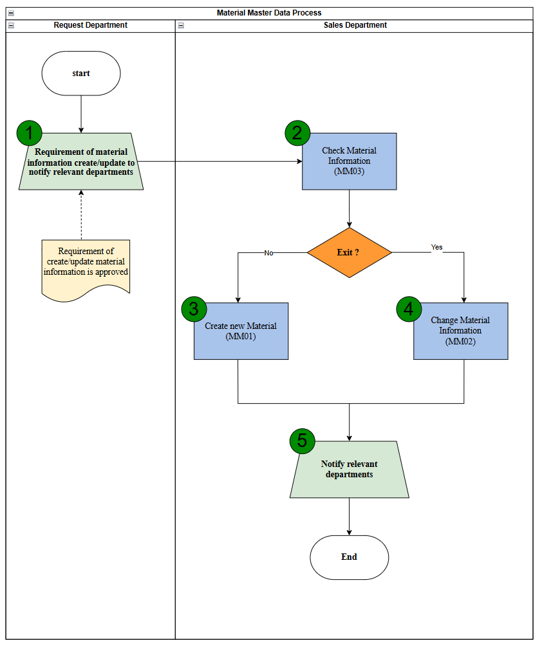

Description
Step | Step Name | Detailed Description | Role
1 | Requirement of material information create/update to notify relevant departments | Input: Request Create Material Information  Explain: An authorized person reviews Material requests before initiating the return process.  Output: Request is approved | Requestor
2 | Check Material Information | Input: Material data  Explain: Verifying and Checking Material Information  If information about the material does not exist, you can go to step 4 to create new information about the material  If material data already exists, it can be changed information about them in step 5 | Warehouse staff
3 | Create new Material | Input: Material information  Explain: Create new Material information  Output: Material master data | Warehouse staff
4 | Change Material Information | Input: Material data  Explain: If the case needs to change material information such as price, quantity,.. | Warehouse staff
5 | Notify relevant departments | Input: Material data  Explain: Inform the relevant department about the information after change or create new material | Warehouse staff

MM-MD-02 Pricing Master Data Process

Pricing Procedures
Pricing Procedure | Description
VTC001 | VinaTech Price

Pricing condition types
Condition type | Copy from Condition type | Description
PRVT | PR00 | VTC Price
ZDIS |  | VinaTech Discount
MWST | MWST | Output Tax

Flowchart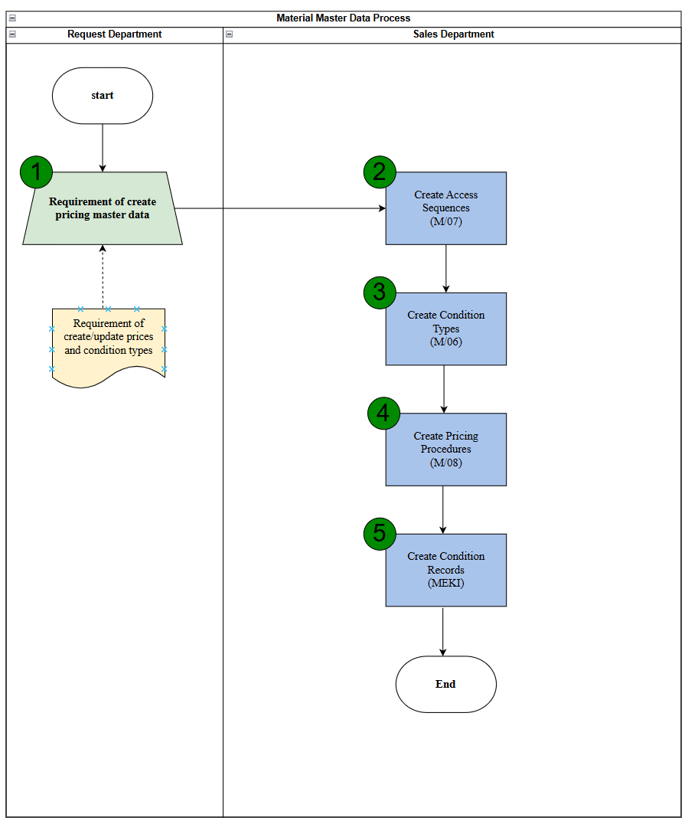

Description
Step | Step Name | Detailed Description | Role
1 | Requirement of Create pricing master data | Input: Request Create Pricing information  Explain: Pricing Master Data has been accurately filled out with the correct pricing strategies and conditions.  Output: Request is approved | Requestor
2 | Create Access Sequences | Explain: Ensures that the pricing procedures are flexible and can accommodate various pricing scenarios. | Sales Staff
3 | Create Condition Types | Explain: Define various pricing conditions such as base price, discounts, surcharges, taxes, freights,.. | Sales Staff
4 | Create Pricing Procedures | Explain: Determines all conditions into one procedure. The prices are calculated based on the condition methods used in. | Sales Staff
5 | Create Condition Records | Explain: Condition Record represents that actual condition value and is stored in a condition key | Sales Staff

PROCUREMENT PROCESS

MM-BP-01 Warehouse release process

Flowchart
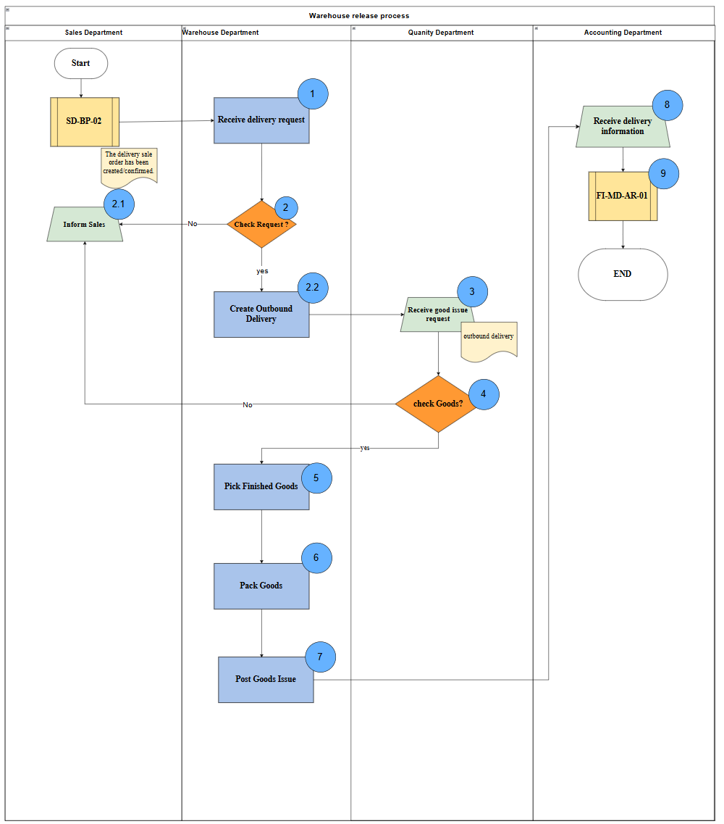

Description
Step | Step Name | Detailed Description | Role
1 | Receive Delivery Request | Input: Sales order / delivery request from Sales Department (SD-BP-02).  Explain: Warehouse Department receives the delivery request and reviews basic information such as product, quantity, and delivery requirements.  Output: Delivery request received and ready for validation. | Warehouse Department
2 | Check Request? | Input: Delivery request data.  Explain: Warehouse verifies the request (availability of goods, completeness of information, delivery conditions). If the request is invalid or incomplete → reject.  Output: Decision (Valid / Invalid request). | Warehouse Department
2.1 | Create Outbound Delivery | Input: Invalid request result.  Explain: Warehouse informs Sales Department about issues (missing data, insufficient stock, incorrect request).  Output: Sales notified; request needs correction. | Sales Department
2.2 | Create Outbound Delivery | Input: Valid delivery request.  Explain: Warehouse creates outbound delivery documents in the system based on confirmed requests.  Output: Outbound Delivery document created. | Warehouse Department
3 | Receive Goods Issue Request | Input: Outbound Delivery document.  Explain: Quality Department receives request to verify goods before issuing (based on outbound delivery).  Output: Goods ready for inspection. | Quality Department
4 | Check Goods? | Input: Physical goods, outbound delivery data.  Explain: Quality Department checks goods condition, quantity, and compliance with delivery requirements. If not qualified → reject and return to Sales.  Output: Decision (Accepted / Rejected goods). | Quality Department
5 | Pick Finished Goods | Input: Approved goods for delivery.  Explain: Warehouse picks goods from storage based on outbound delivery document.  Output: Goods picked and prepared for packing. | Warehouse Department
6 | Pack Goods | Input: Picked goods.  Explain: Warehouse packs goods according to delivery standards and requirements (labeling, packaging, documentation).  Output: Goods packed and ready for shipment. | Warehouse Department
7 | Post Goods Issue | Input: Packed goods, outbound delivery document.  Explain: Warehouse posts Goods Issue in the system, reducing inventory and confirming shipment.  Output: Goods Issue posted; inventory updated. | Warehouse Department
8 | Receive Delivery Information | Input: Goods Issue data, delivery confirmation.  Explain: Accounting Department receives delivery information for financial processing.  Output: Delivery data available for accounting. | Accounting Department
9 | Process Accounting Entry (FI-MD-AR-01) | Input: Delivery data, billing rules, customer account.  Explain: Accounting performs financial posting such as billing, revenue recognition, and accounts receivable update.  Output: Financial documents created (invoice, accounting entries). | Accounting Department

MM-BP- Return Process

Flowchart 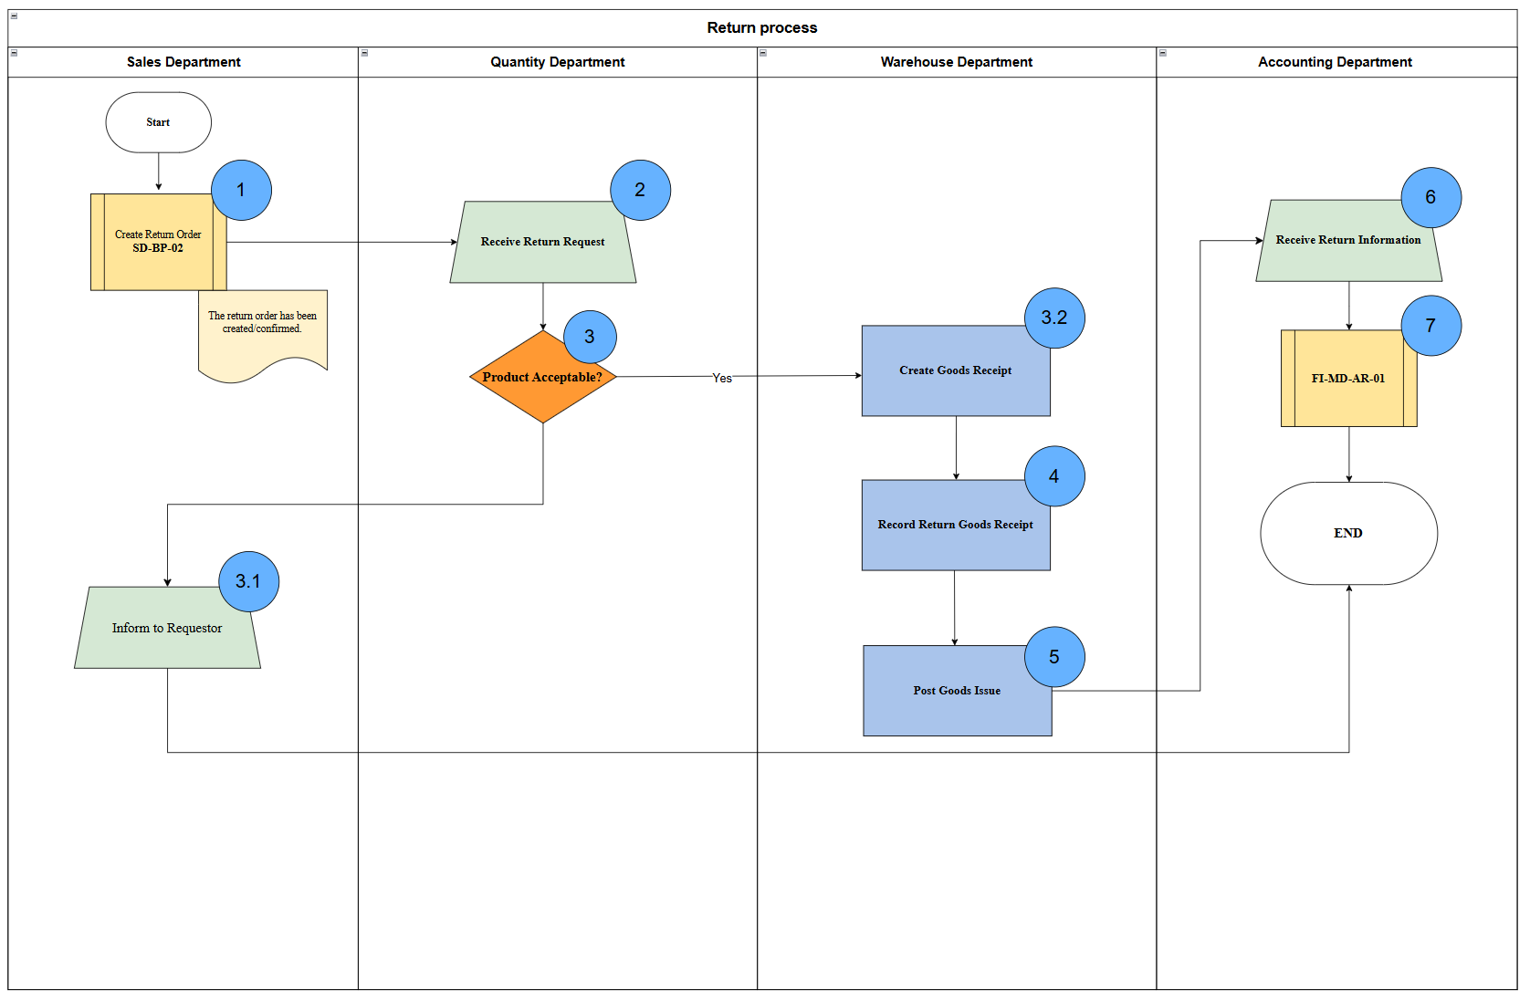

Description
Step | Step Name | Detailed Description | Role
1 | Create Return Order (SD-BP-04) | Input: Customer return request, sales order reference, return reason.  Explain: Sales Department creates a return order in the system based on customer request. The order is validated for correctness (product, quantity, pricing, return conditions) and then confirmed.  Output: Return Order created and confirmed in the system. | Sales Department
2 | Receive Return Request | Input: Return Order from Sales Department.  Explain: Quality Department receives and reviews the return request, verifying product details, return reason, and supporting documents.  Output: Return request validated and ready for evaluation. | Quality Department
3 | Product Acceptable? | Input: Return request details, product condition criteria, return policy.  Explain: Quality Department evaluates whether the returned product meets acceptance criteria (e.g., damage level, warranty status, return policy compliance). Decision is made: Accept or Reject.  Output: Decision result (Accept / Reject). | Quality Department
3.1 | Inform to Requestor | Input: Rejection decision from Step 3.  Explain: Sales Department informs the requester (customer) about the rejection along with explanation and reason for refusal.  Output: Customer notified of rejection; process terminated. | Sales Department
3.2 | Inspect Returned Goods | Input: Accepted return decision, physical returned goods.  Explain: Warehouse (or Quality) inspects the returned goods physically to verify condition, quantity, and compliance with return requirements.  Output: Inspection result confirmed (goods condition & quantity validated). | Warehouse Department
4 | Record Return Goods Receipt | Input: Inspection result, returned goods.  Explain: Warehouse records goods receipt in the system. Inventory is updated to reflect returned items (stock increase or specific storage location update).  Output: Goods receipt posted; inventory updated. | Warehouse Department
5 | Post Goods Issue | Input: Goods receipt data, inspection outcome.  Explain: Warehouse processes further goods movement depending on condition (e.g., return to stock, scrap, or send for repair). System posting is executed accordingly.  Output: Goods movement posted (stock updated / adjusted). | Warehouse Department
6 | Receive Return Information | Input: Return transaction data from warehouse (goods movement, return order).  Explain: The Accounting Department receives return-related information for financial processing.  Output: Financial processing request prepared. | Accounting Department
9 | Process Accounting Entry (FI-MD-AR-01) | Input: Return order, goods movement data, financial rules.  Explain: Accounting performs financial postings such as credit memo creation, accounts receivable adjustment, and reconciliation with original invoice.  Output: Financial documents posted (credit memo, accounting entries). | Accounting Department

